**Write SQL statement for the following**

1. 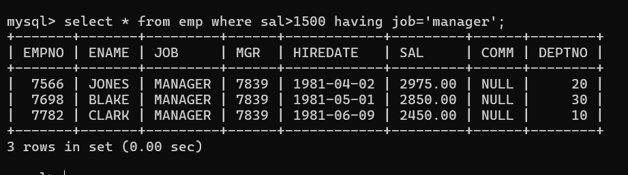To find all managers with salary >1500
2. 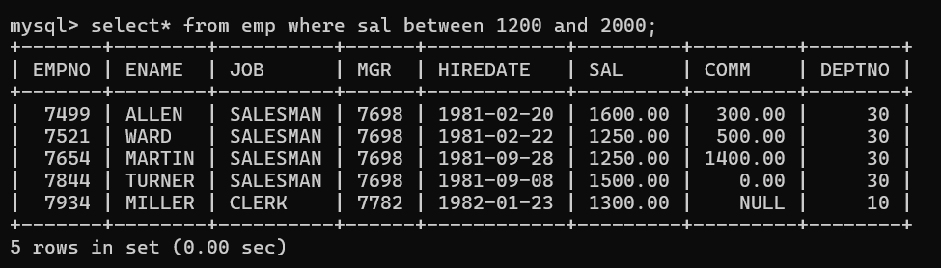list all employees with sal >1200 and < 2000
3. 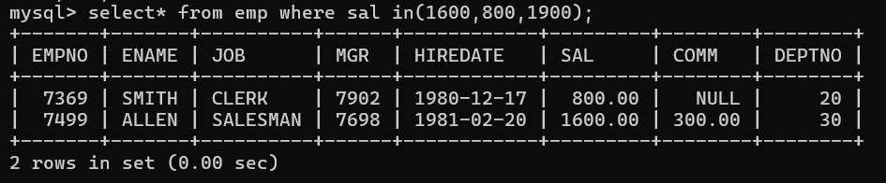list all employees with sal is 1600 or sal is 800 or sal is 1900
4. list all employees with R at second last position in name
5. 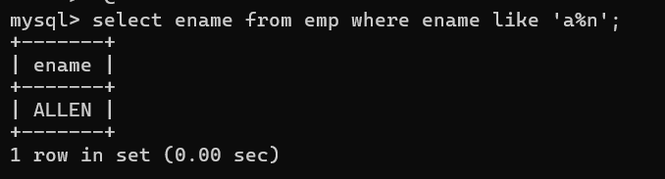List all employees with name starts with A and ends with N

**Q2. Solve following**

* 1. 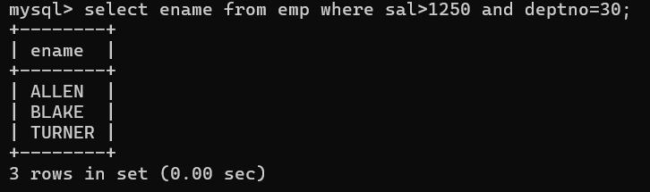list all employees with salary > 1250 and dept no=30
  2. 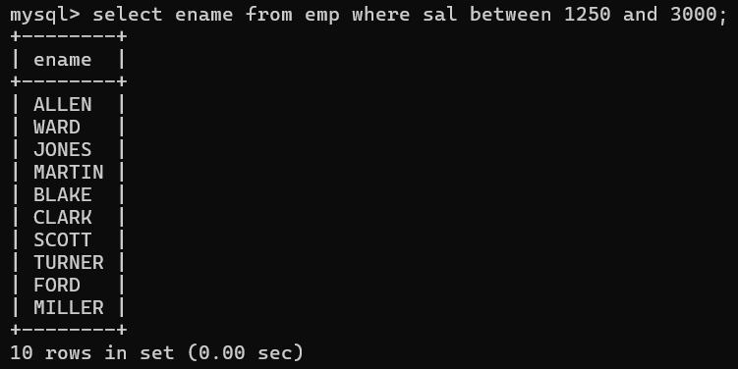list all employees with salary >=1250 and <= 3000
  3. 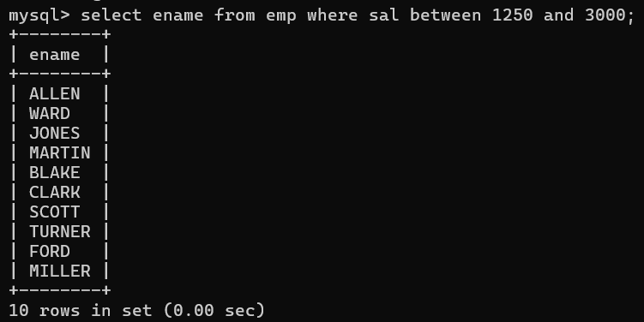list all employees with salary >1250 and < 3000
  4. 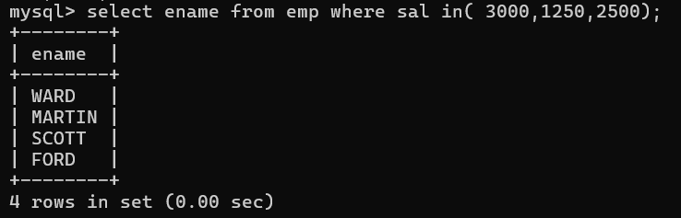list all employees with salary either equal to 3000 or 1250 or 2500
  5. 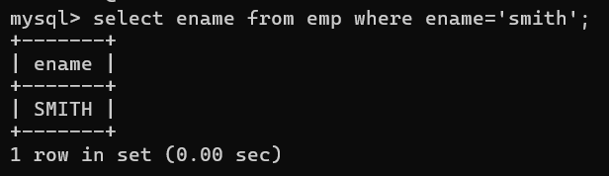list all employee with name=SMITH
  6. 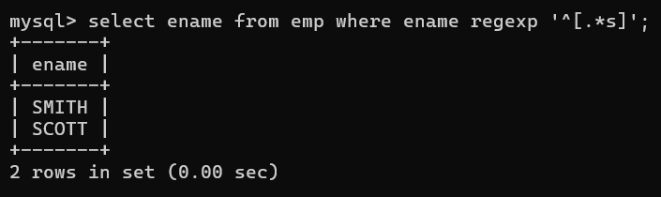list all employees with name starting with S
  7. 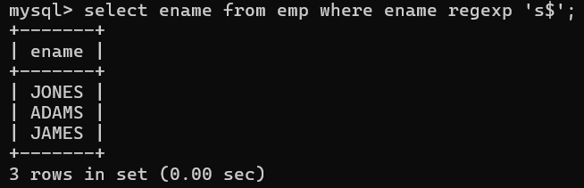list all employees with name ending with S

1. 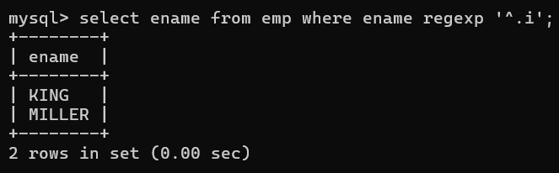list all employees with name contains I at 2nd position
2. 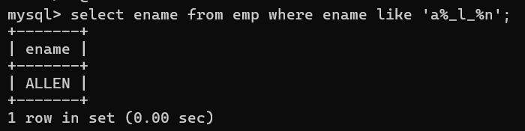list all employees with name starts with A ends with N and somewhere in between L is there
3. list all employees with name starts with A and B at 3 rd position and P at second last position
4. 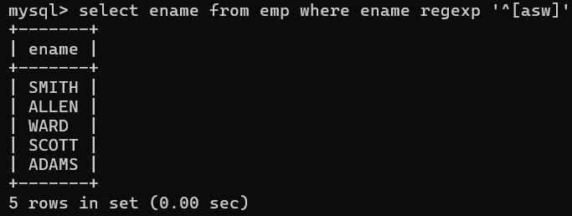List all employees with name starts with either A or starts with S or starts with W
5. 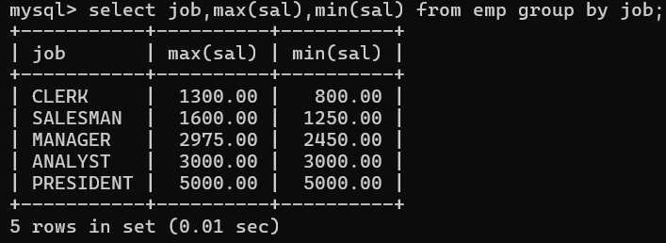find max sal and min sal for each job
6. 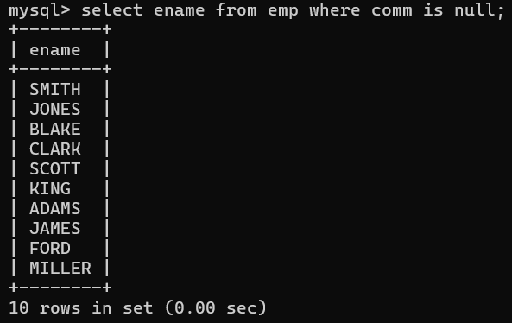**find how many employess have not received commission**
7. 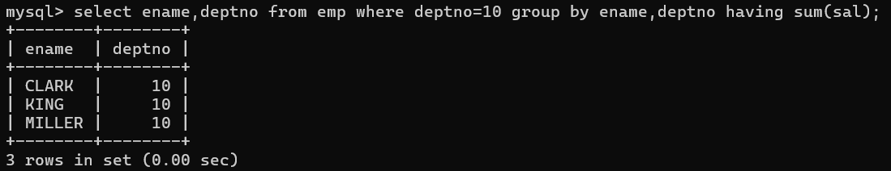**find sum of sal of all employees working in dept no 10**
8. 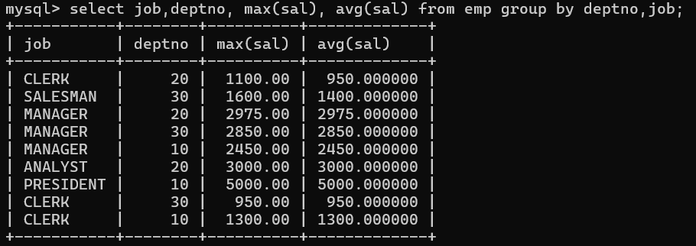**find maximum salary,average sal for each job in every department**
9. 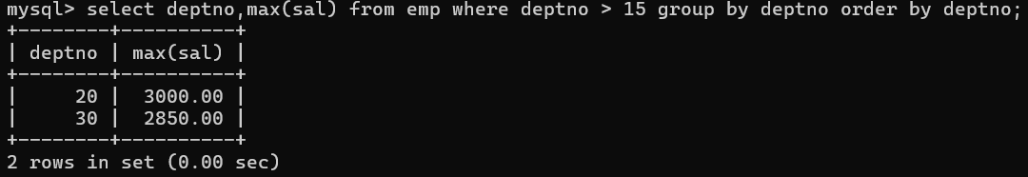**find max salary for every department if deptno is > 15 and arrange data in deptno order.**
10. 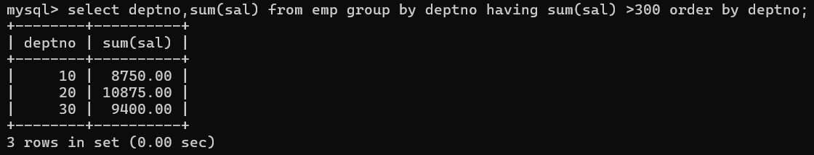**find sum salary for every department if sum is > 3000**
11. 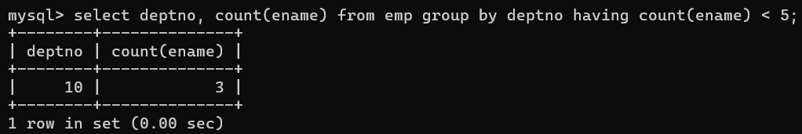**list all department which has minimum 5 employees**
12. 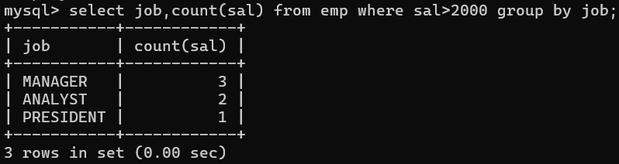**count how many employees earn salary more than 2000 in each job**
13. 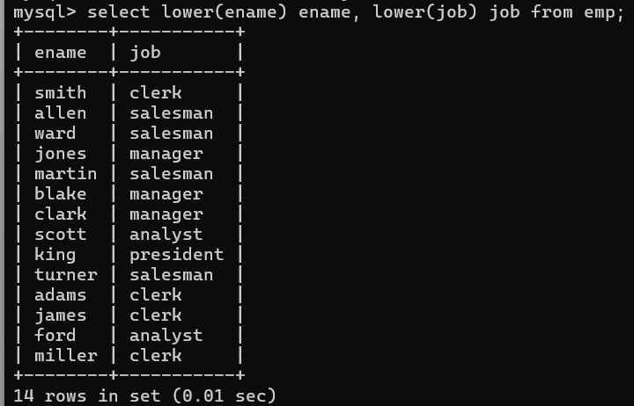**list all enames and jobs in small case letter**
14. 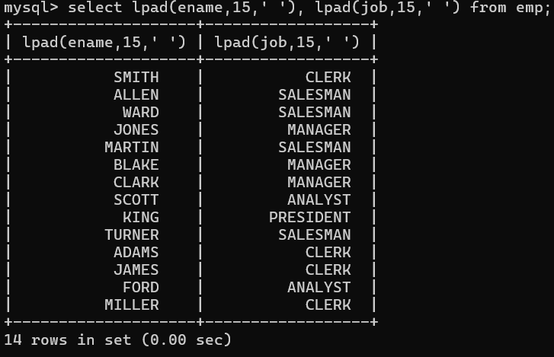**list all names and jobs so that the length of name should be 15 if it is smaller then add spaces to left**
15. **display min sal,max sal, average sal for all employees working under same manager**
16. 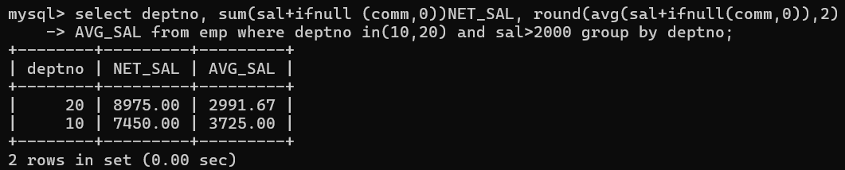**find sum of total earnings(sal+comm), average of sal+comm, for all employees who earn sal > 2000 and work in either dept no 10 or 20**
17. **list all employees who joined in Aug 1980 and salary is >1500 and < 2500**
18. 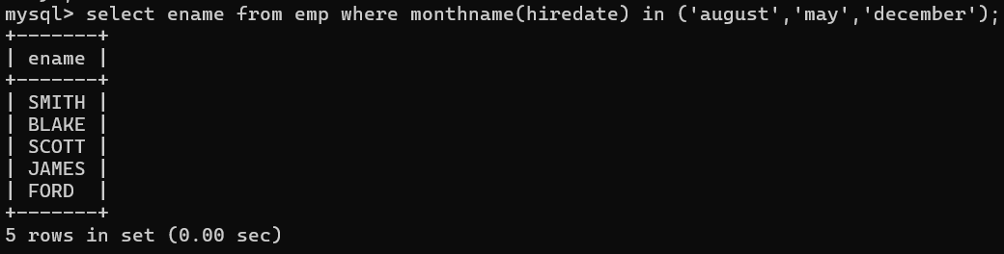**list all employees joined in either aug or may or dec**
19. **display name and hiredate in dd/mm/yy format for all employees whose job is clerk and they earn some commission**